**Python**

Om Ghanshyam Bhamare

SE A 3

Github:

**Assignment 3**

**Q1. A python program to create three push buttons and change the background of the frame according to the button clicked by the user.**

1] First Frame Without Bg color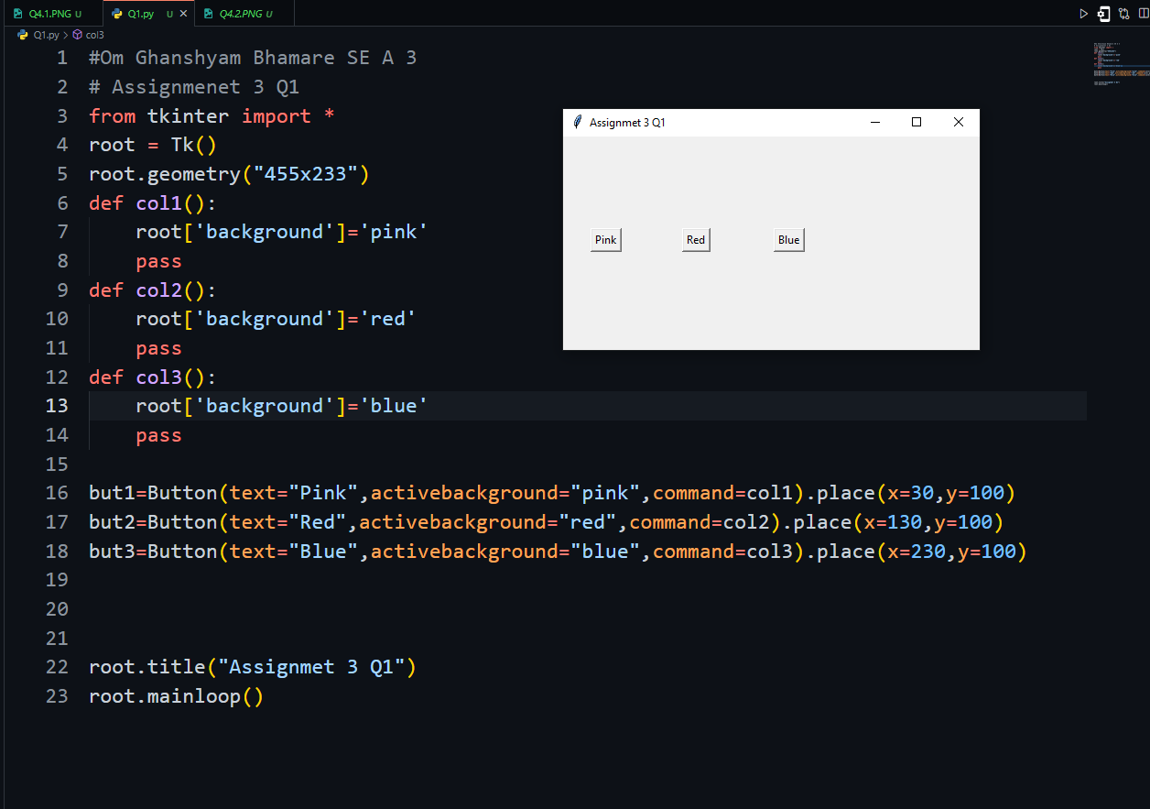

2]Screen After click on pink button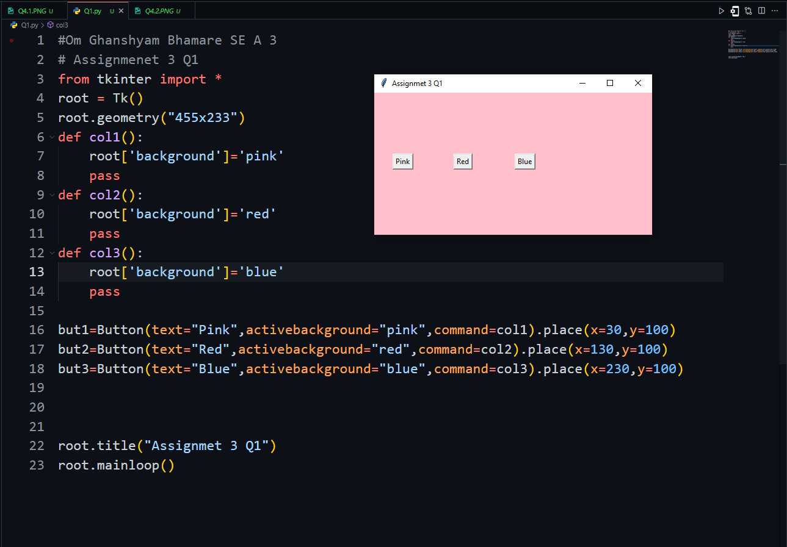

3]Screen After click on red button 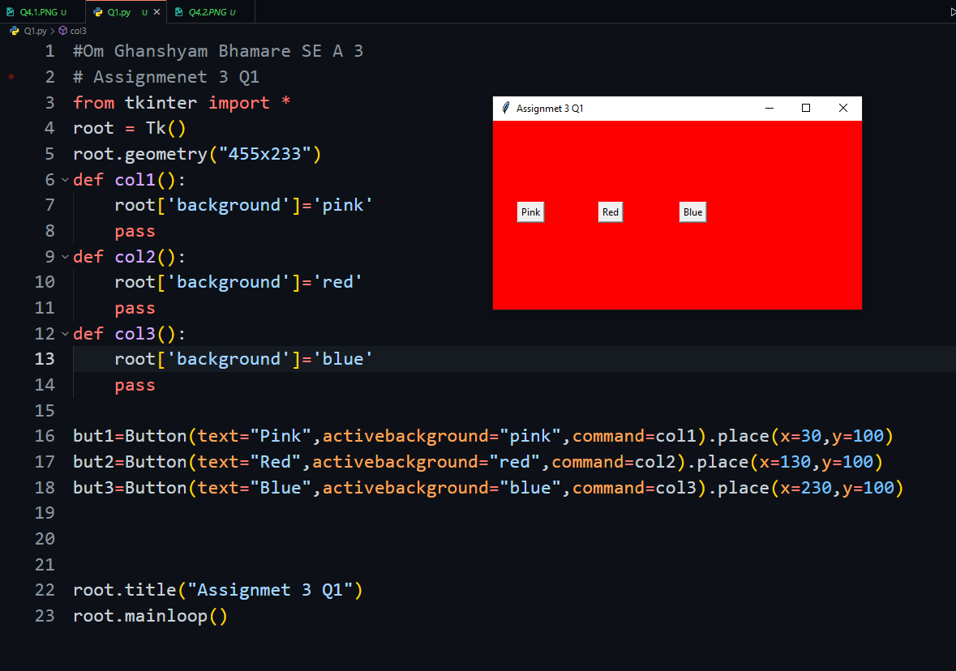

4]Screen After click on Blue button 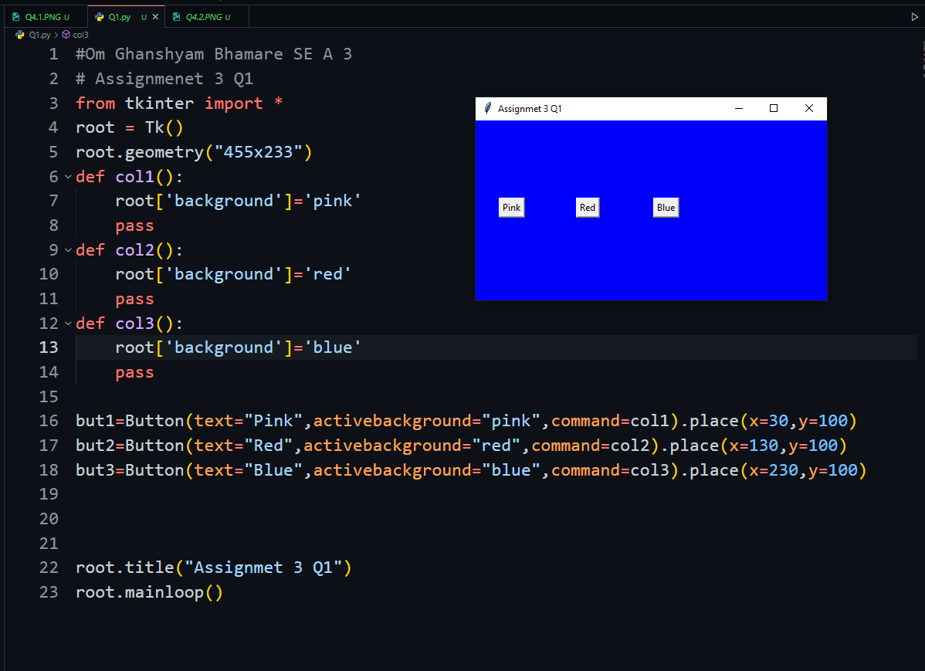

**Q2.** **Create a Django Framework to display the following details of a Student in a web page. (The details**

**must be extracted from the database)**

**• Name**

**• Age**

**• Department**

**• Current Sem**

**• Address**

**• Total CGPI**

**1]Students model created**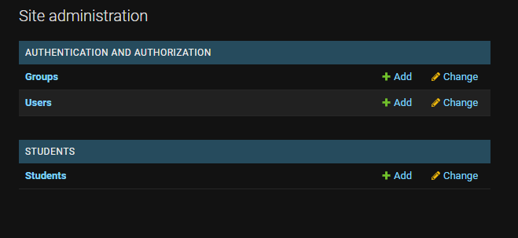

**2]Initially no data in Model** 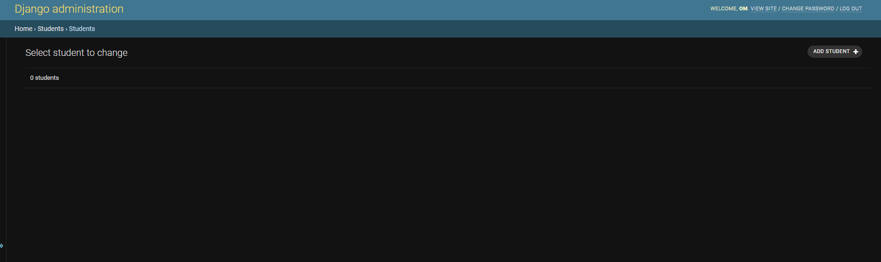

**3]No data display on webpage**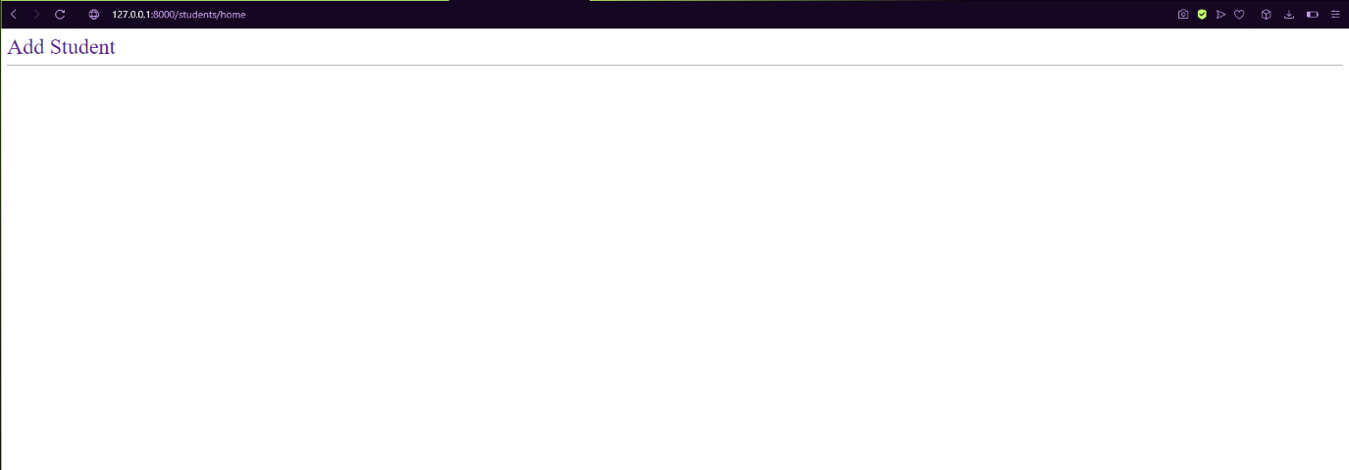

**4]Student information adding form**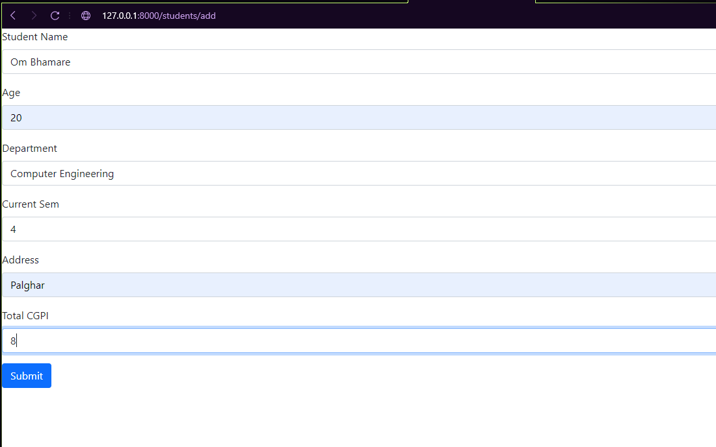

**5]Information display on webpage after adding information**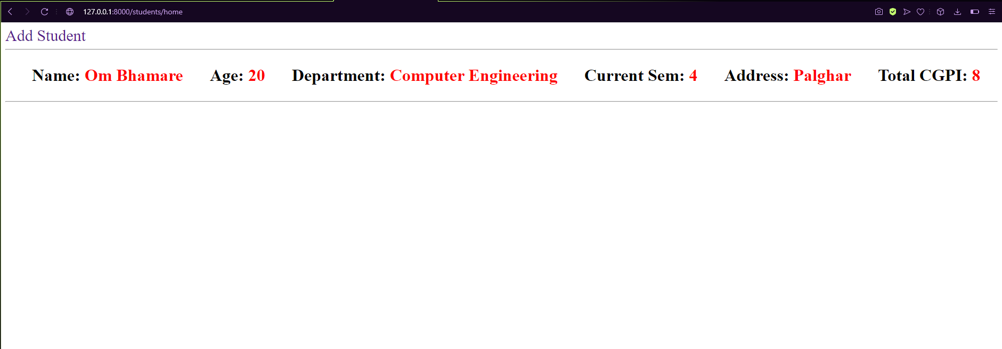

**6]Added more data and display it**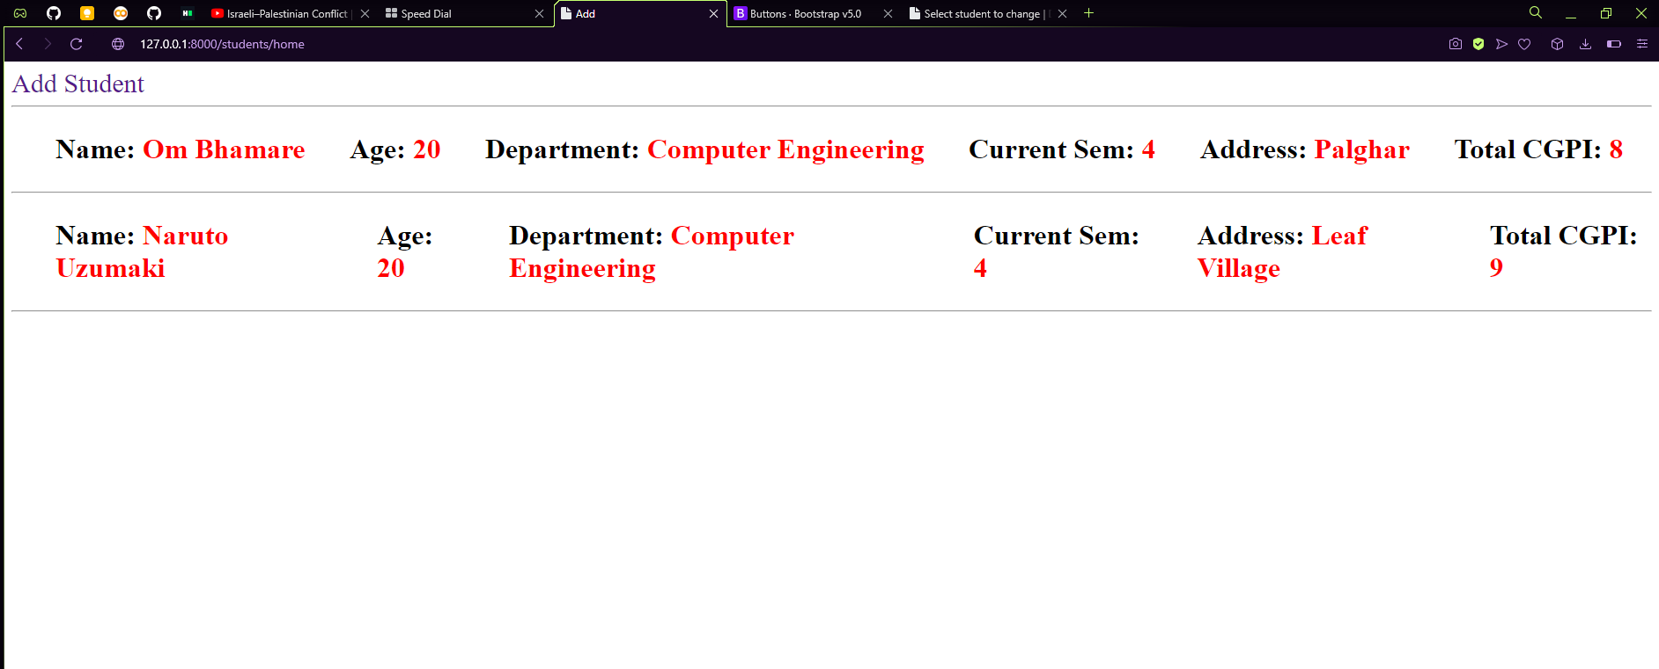

**7]Added data in Student model**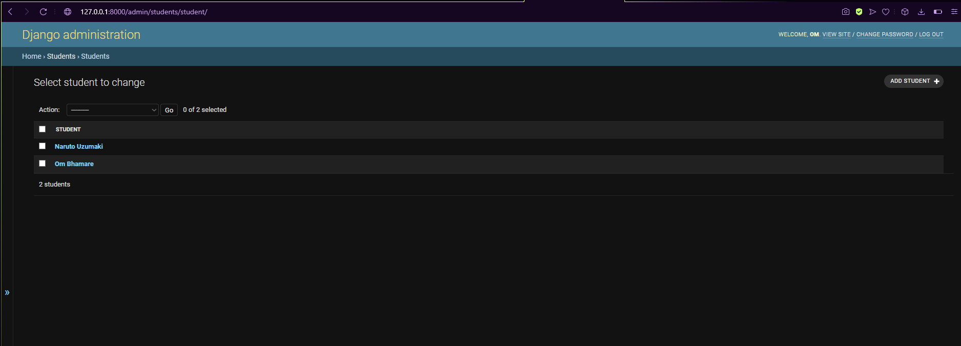

**Q3.** **Demonstrate the working of CRUD in Python database for a vaccine data**

**1]Covid Database Created**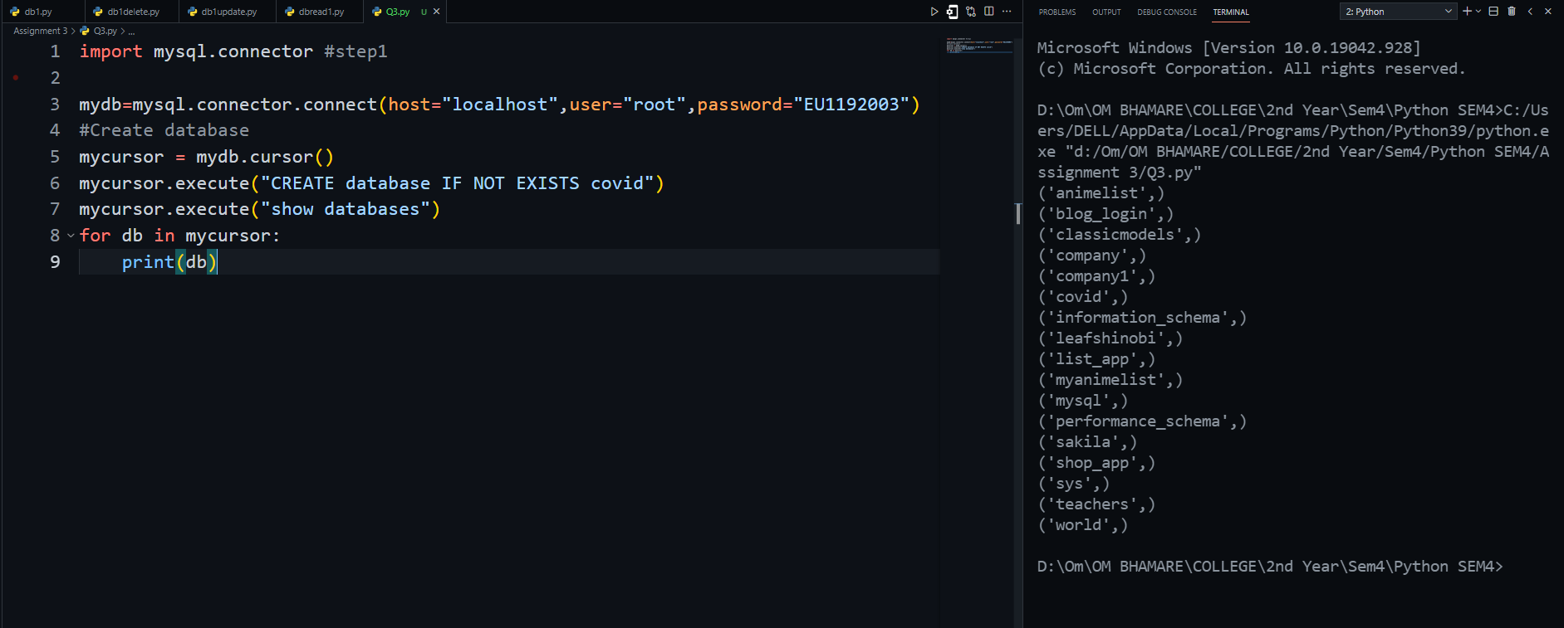

**2]Created Table**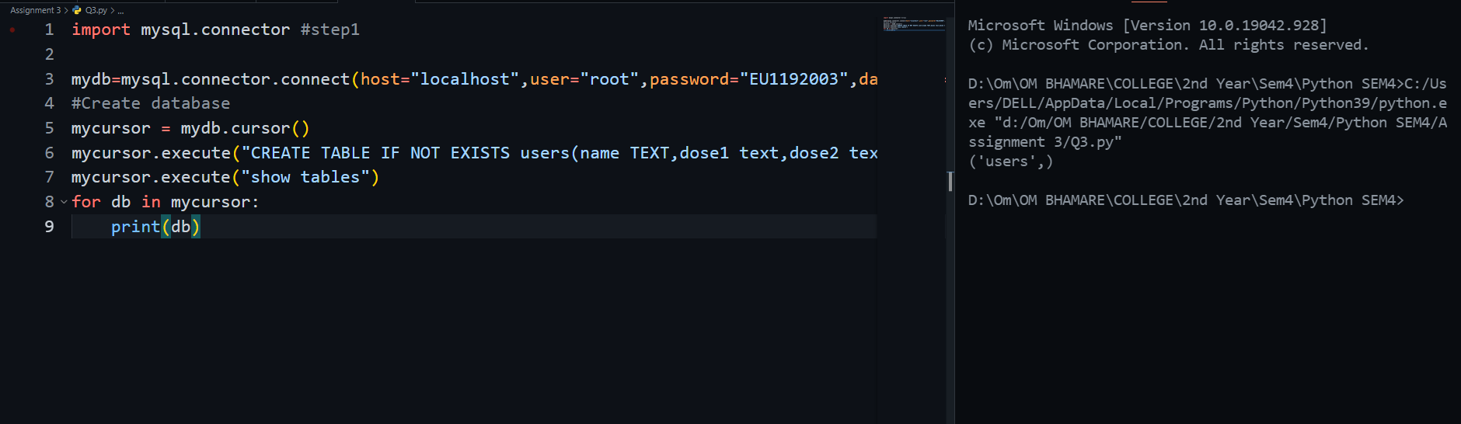

**3]Added data in Tabel**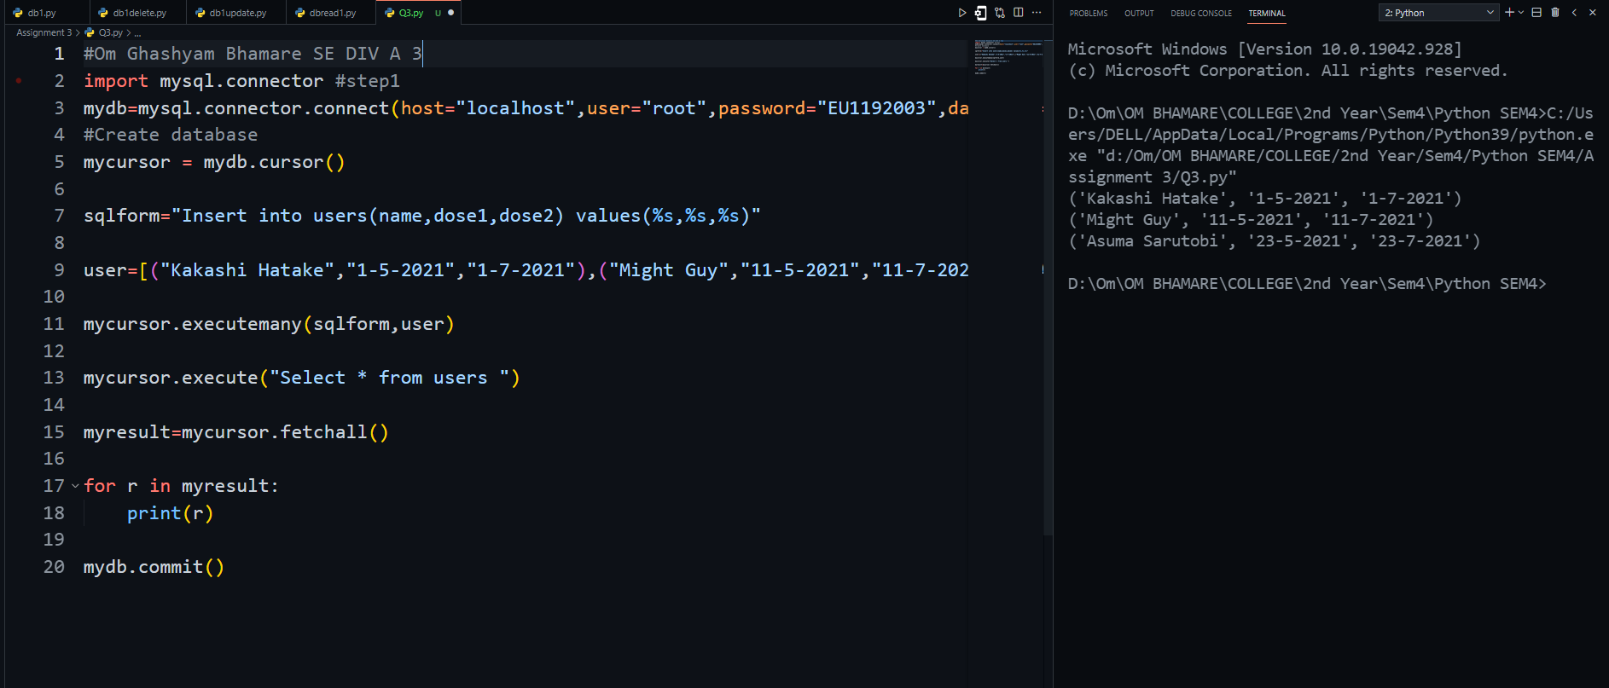

**3]Updated data in table**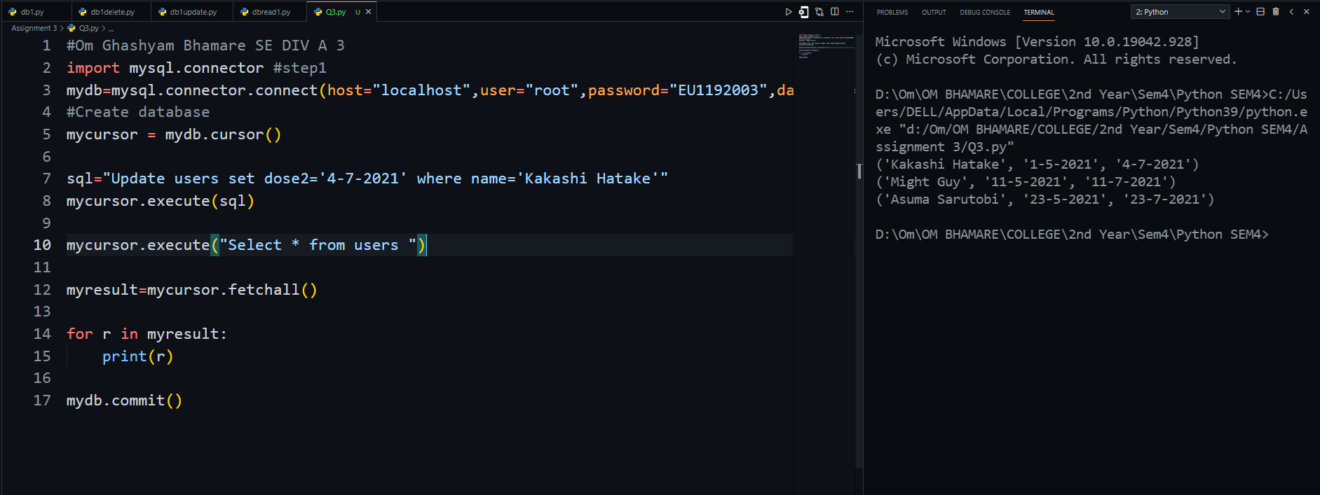

**4]Delete data in table**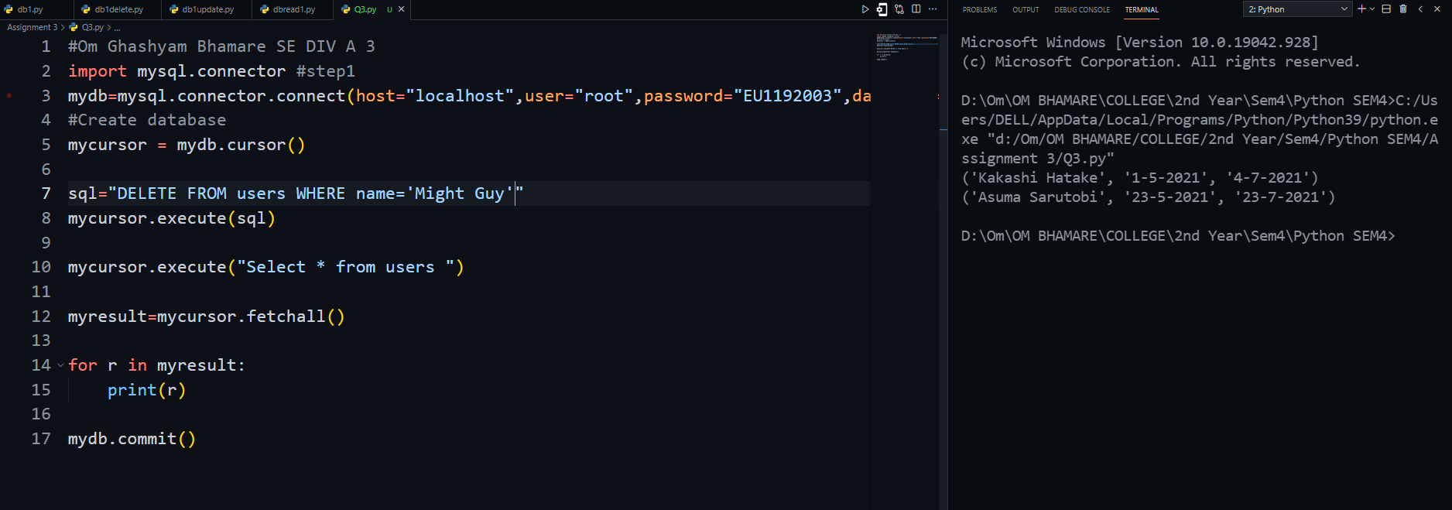

**Q4.** **A python program to show progress of a SE COMP A and B using pie chart and line graph**

**1]Piechart**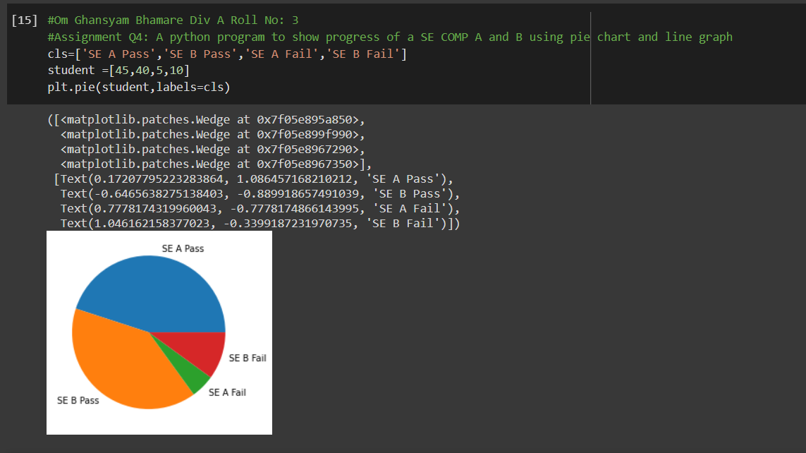

**2]Line Graph**